OPERATING SYSTEM
(PRACTICAL LAB)

Manav Rachna International Institute of Research and
Studies
School of Computer Applications
Department of Computer Applications

Submitted By
Student Name | ^{ISHA RAWAT}
Roll No | 24/SCA/BCA (CS)/007
Programme | B.C.A. Cyber security
Semester | 4th Semester
Section/Group | 4 D
Department | Computer Applications
Batch | 2024-2027
Submitted To
Faculty Name | Dr. Anupriya Jain

1. Basics of UNIX commands and Implementation of Shell Programming Apply (Analyse (functional code )
Input:
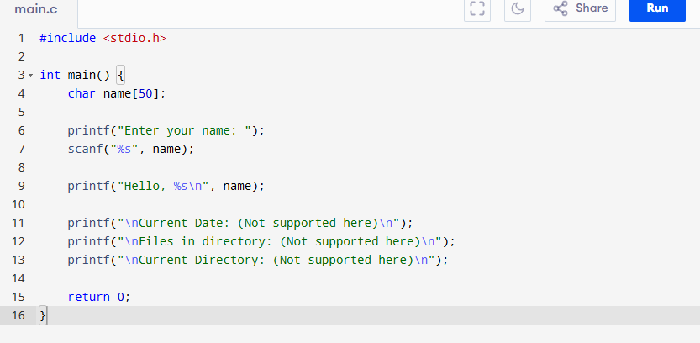
Output
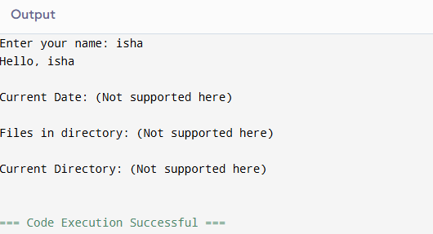
2. Write a C/C++ program for process creation and termination. Apply (Analyse (functional code )
Input
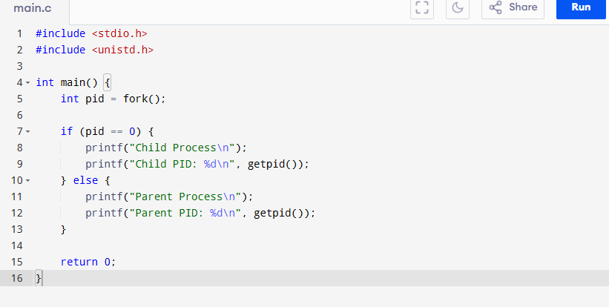
Output
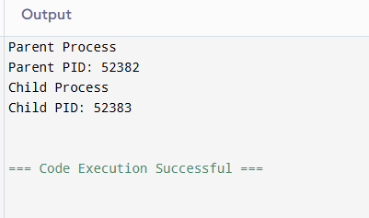

3. Write a C program to demonstrate the use of basic system calls. Apply (Analyse (System call functional code )
Input
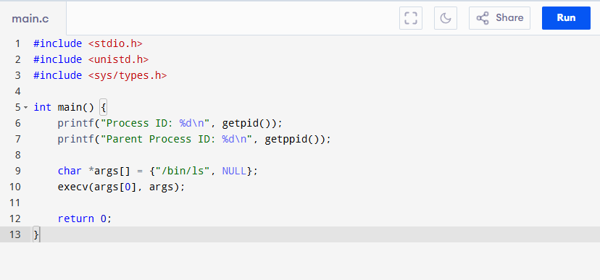
OUTPUT
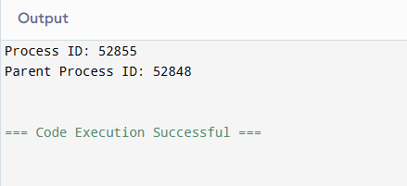

4. Write a program to take system resources as input and apply Banker's algorithm to avoid deadlock. Apply ( Deadlock Functional Codes)
INPUT
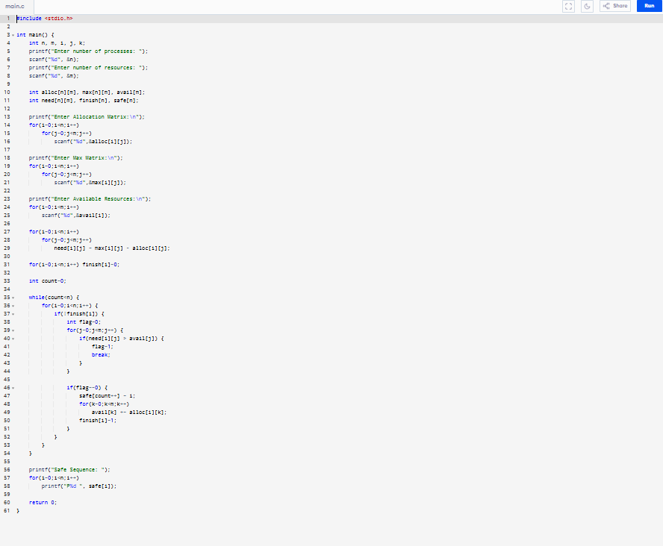
OUTPUT
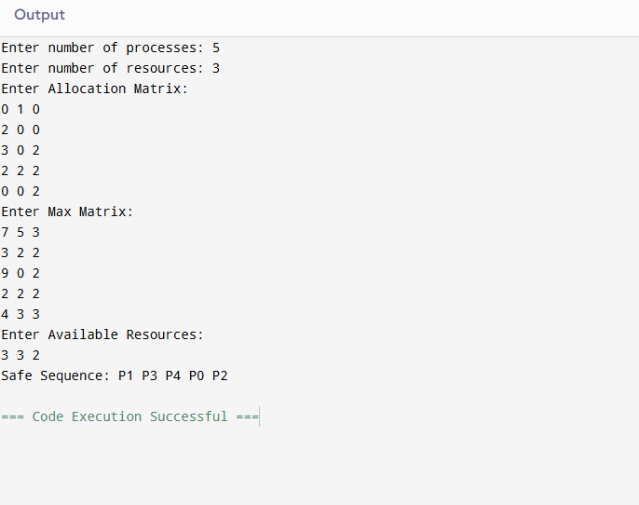

5. Write a C/C++ program for thread creation and termination. Apply (Array manipulation, stack & queue operations)
INPUT
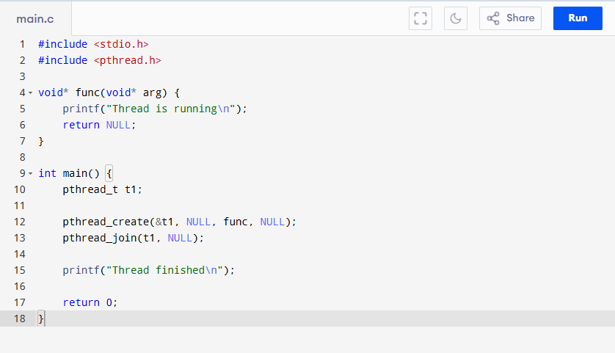
OUTPUT
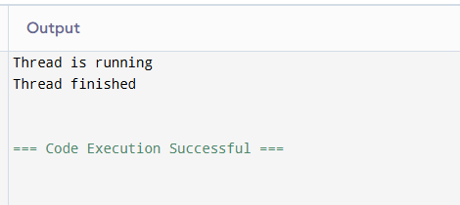

6. Write a C/C++ program to simulate HRRN CPU scheduling algorithms to find average turnaround time and average waiting time.(Take User input). Apply ( CPU scheduling algorithms)
INPUT
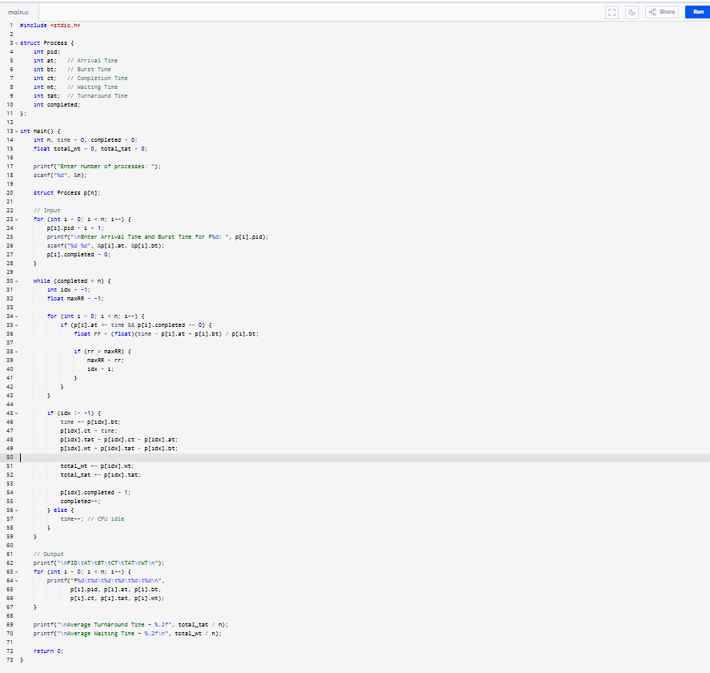
OUTPUT
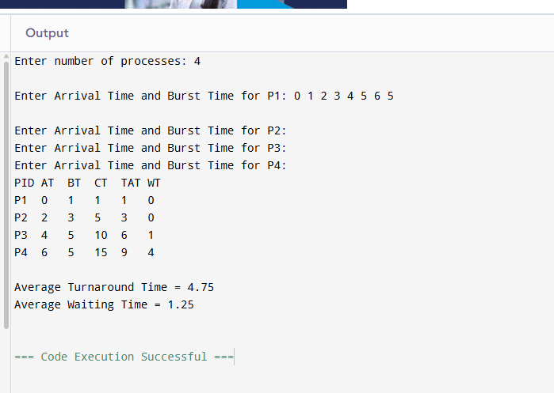

7. Simulate First Come First Serve and Shortest Job First scheduling algorithms using arrays. Apply (scheduling algorithms )
INPUT
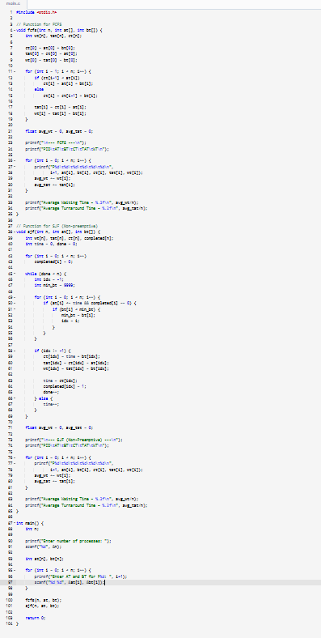
OUTPUT
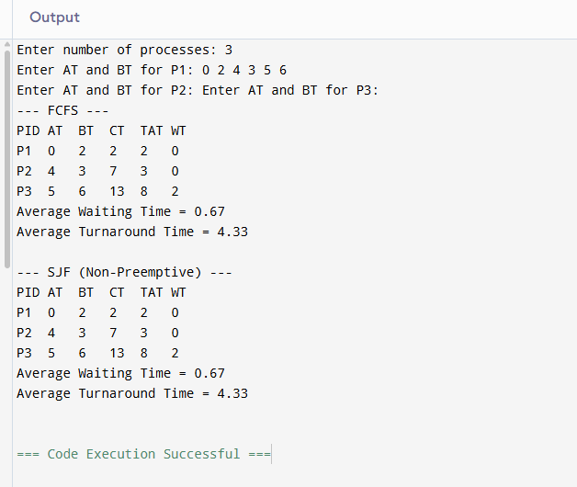

8. Implement a Round Robin scheduling algorithm with user-defined time quantum. Show context switching simulation. Apply (scheduling algorithms/Switching Functional code)
INPUT
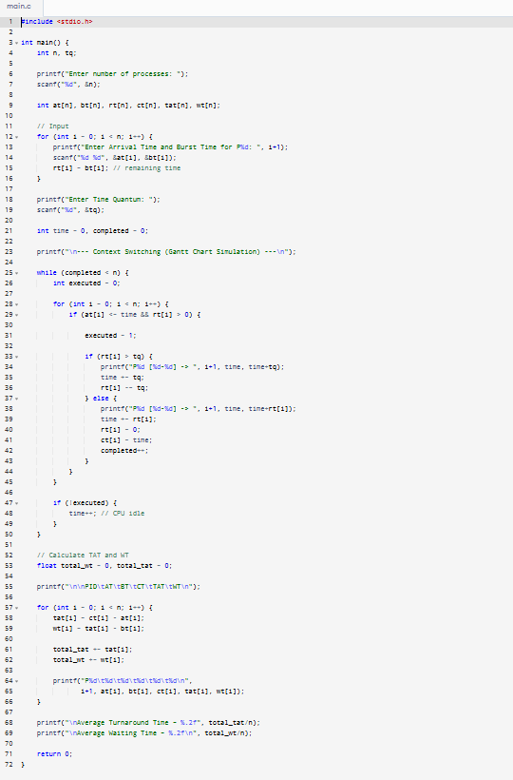
OUTPUT

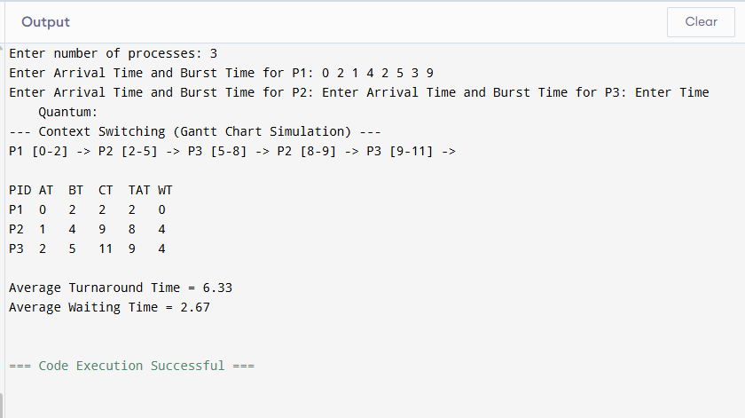

9. Write a C/C++ program to simulate the following non preemptive CPU scheduling
algorithms to find average turnaround time and average waiting time. (Provide user inputs)
a) FCFS b) SJF c) SRTF d) Priority Based. Apply (scheduling algorithms functional code)
INPUT
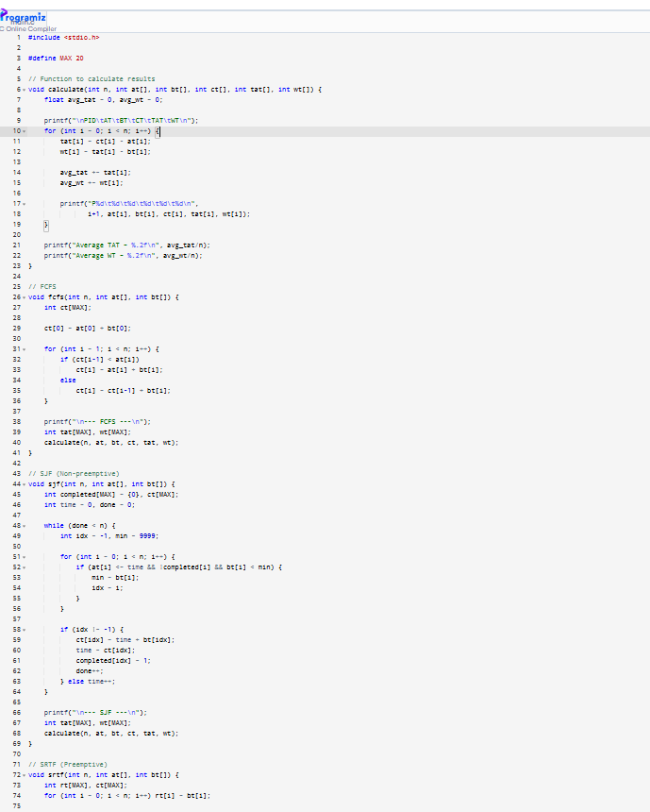
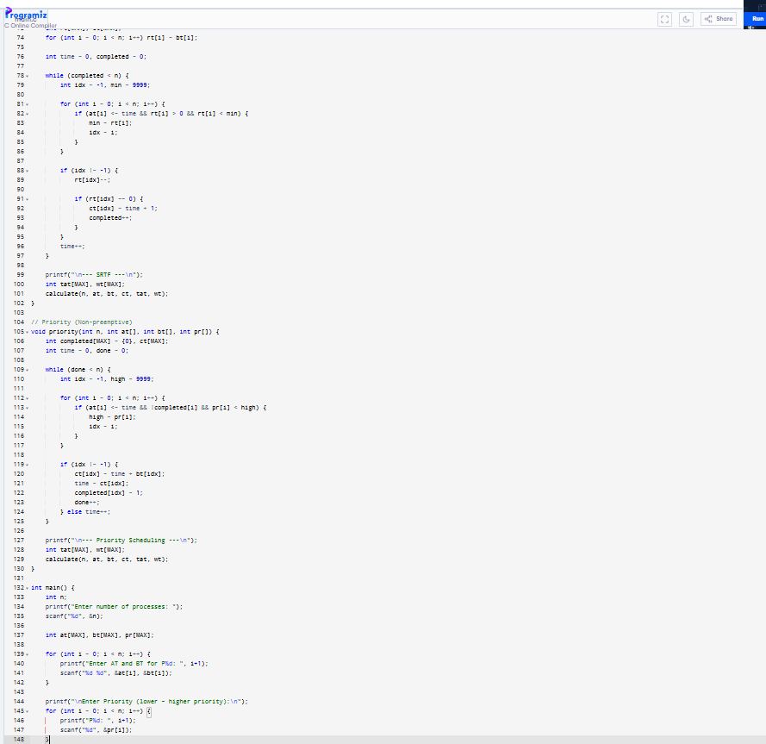
OUTPUT
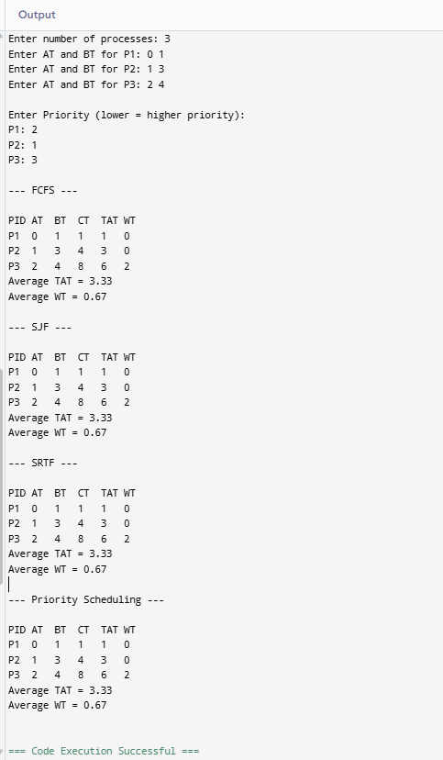

10. Write a C/C++ program to simulate producer- consumer problem using semaphores. Apply (semaphores functional code )
INPUT
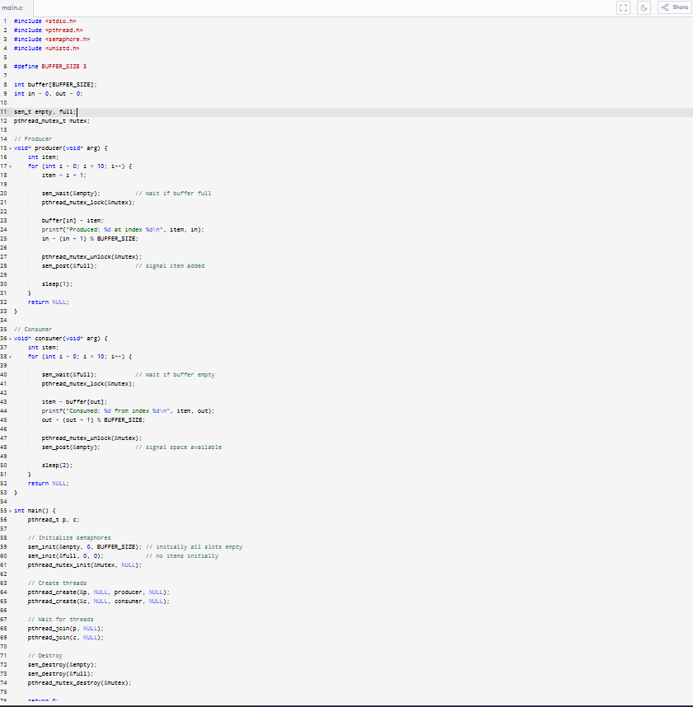
OUTPUT
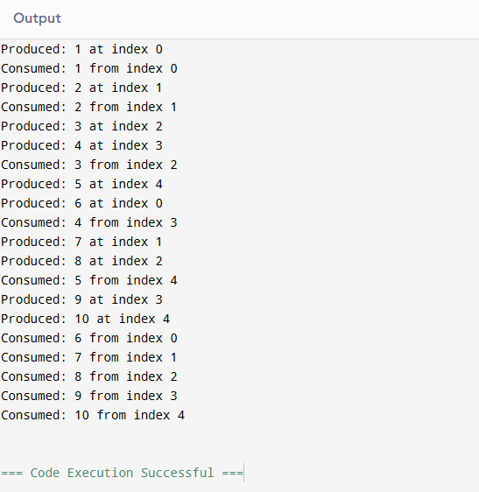

11. Write a C/C++ program to simulate reader-writer problem using semaphores. Apply (Binary tree traversal)
INPUT
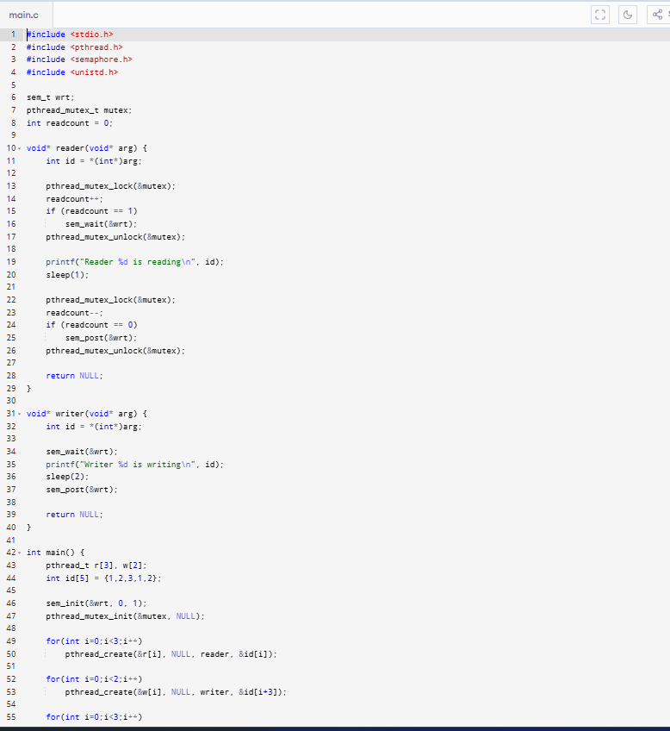
OUTPUT
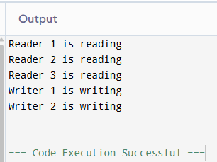
12. Write a C program to implement and compare FIFO, LRU, and Optimal page replacement algorithms. Apply (functional code)
INPUT
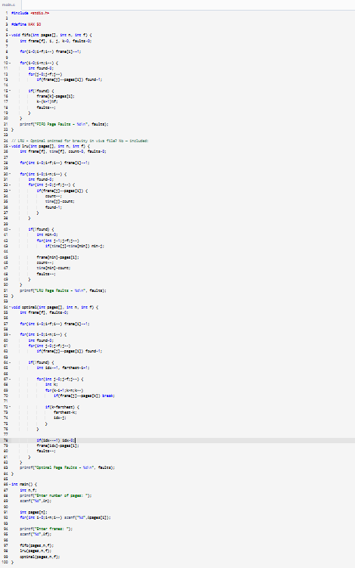
OUTPUT
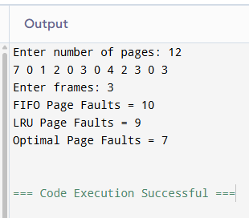

13. Create a simple text-based file system that supports file creation, deletion, and search using indexed or linked allocation methods. Apply (functional code)
INPUT
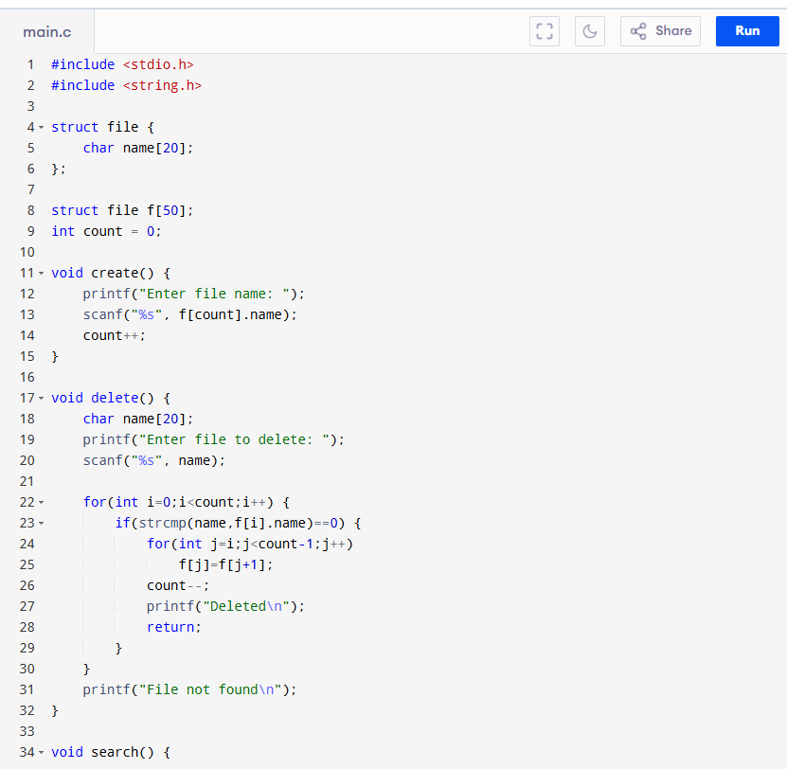
OUTPUT
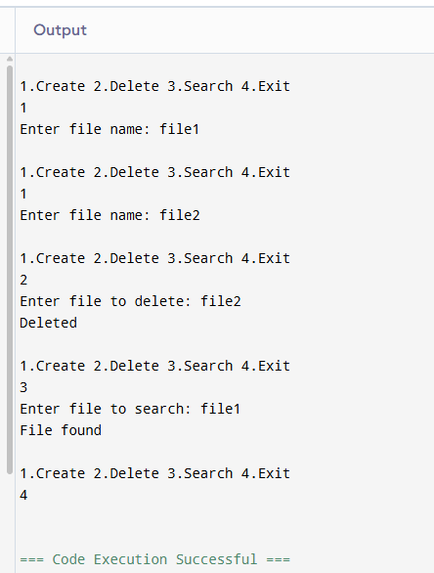

14. Write a program to read and display process information from the /proc directory in Linux. Apply (functional code)
INPUT
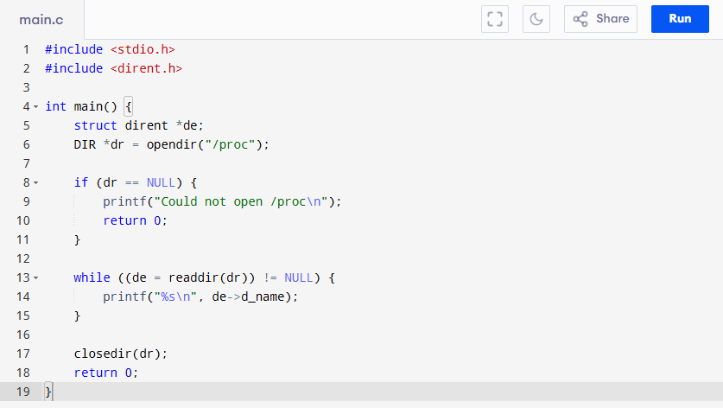
OUTPUT
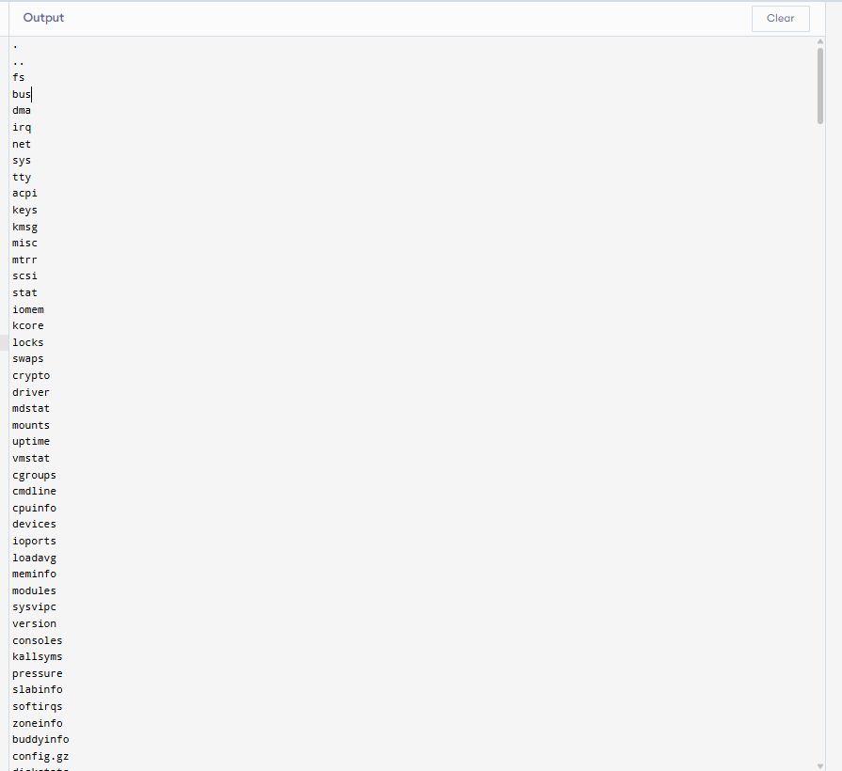

15. Write a C/C++ program to simulate Multilevel Queue CPU scheduling algorithms to find the average turnaround time and average waiting time (Processes P0, P1, P4 in Queue 1 and Processes P2, P3 in Queue 2).
INPUT
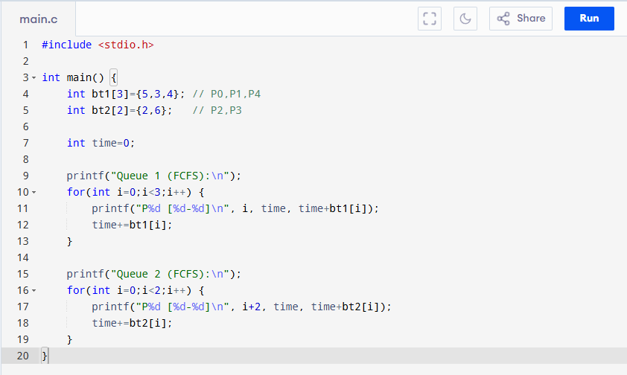
OUTPUT
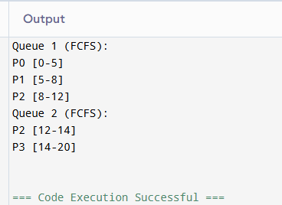
16. Write a C/C++ program to simulate Multilevel Feedback Queue CPU scheduling algorithms to find average turnaround time and average waiting time, where queues 1 and 2 follow round robin with time quantum 4 and 8, respectively and queue 3 follow FCFS. Apply (functional code)
INPUT

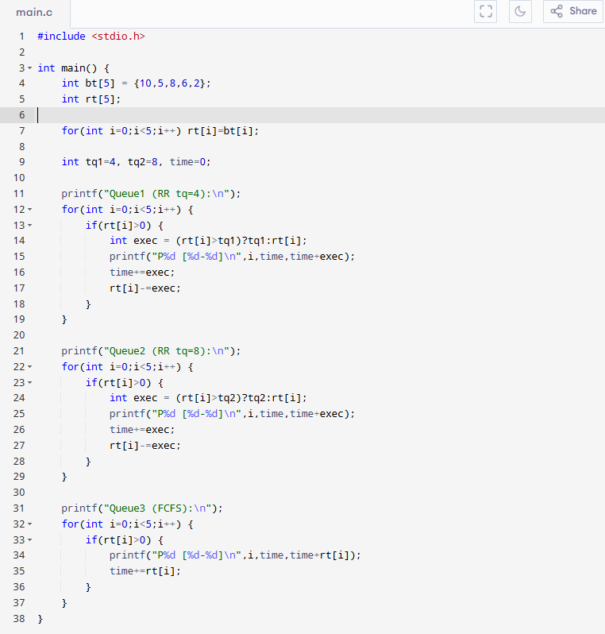
OUTPUT
